Creating a simple image application in APEX

This is the first part of a series of 3 to be followed in order.

In SQL Developer, create a table to hold your images

CREATE TABLE images

(image_id NUMBER CONSTRAINT images_image_id_pk PRIMARY KEY,

filename VARCHAR2(100),

image ORDSYS.ORDImage,

thumbnail BLOB);

Note the data type of the thumbnail. This is to ensure that APEX is capable of handling the thumbnail in a report.

Set up a sequence to use to generate a primary key.

CREATE SEQUENCE seq_image_id

START WITH 1

INCREMENT BY 1

NOCACHE;

Note that a trigger to populate the primary key is not used in this example.

Create a procedure to load some test images located on the server into the table[1].

CREATE OR REPLACE PROCEDURE load_image_from_file

(p_filename IN VARCHAR2) AS

l_image_id INTEGER;

l_image ORDSYS.ORDImage;

ctx RAW (64) := NULL;

BEGIN

INSERT INTO images

(

image_id,

filename,

image

)

VALUES

(

seq_image_id.nextval,

p_filename,

ORDSYS.ORDImage

('FILE',

'ISAD353_IMAGES',

p_filename,

1 -- setProperties, default is 0

)

)

RETURNING image_id, image INTO l_image_id, l_image;

-- useful INSERT variant

l_image.import(ctx);

-- explicit property setting if needed

-- l_image.setProperties();

UPDATE images

SET image = l_image

WHERE image_id = l_image_id;

COMMIT;

EXCEPTION

WHEN others THEN

BEGIN

ROLLBACK;

dbms_output.put_line(sqlerrm);

END;

END;

And then call it to load two test images:

BEGIN

load_image_from_file('j0145773.jpg');

load_image_from_file('j0144687.jpg');

END;

Navigate to the images table and select the data tab – you should see that the two rows have been inserted

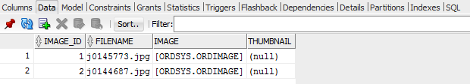

Double click on [ORDSYS.ORDIMAGE] and click the pencil icon to reveal the ORDIMAGE object type attribute values.

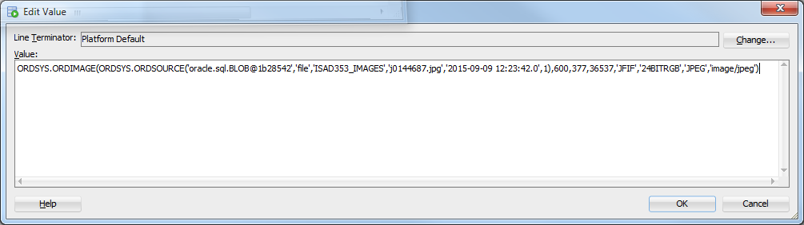

In APEX, create a new Desktop application called **Images**.

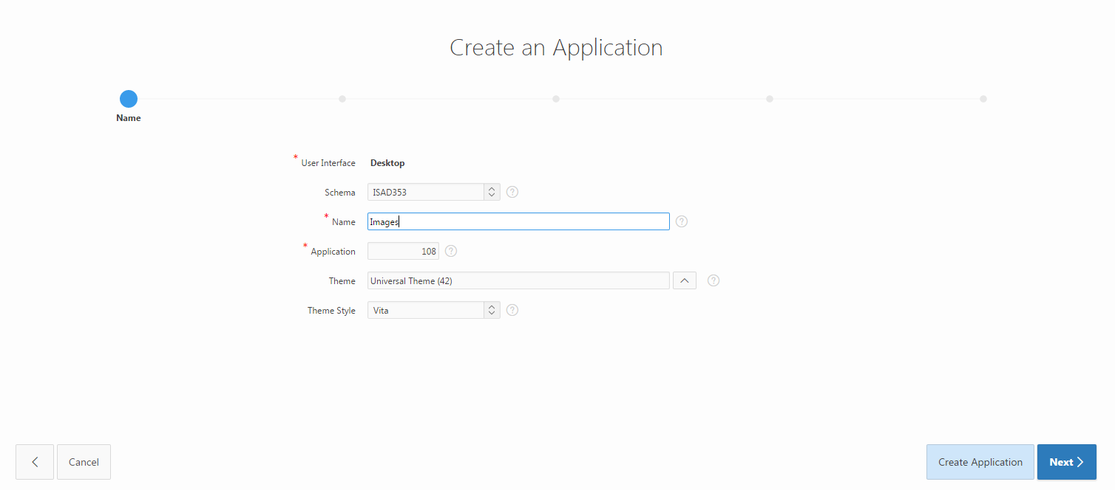

Add a Report and Form Page based on your Images table.

Ensure that you select a **Classic** Report (i.e. not Interactive, which is the default).

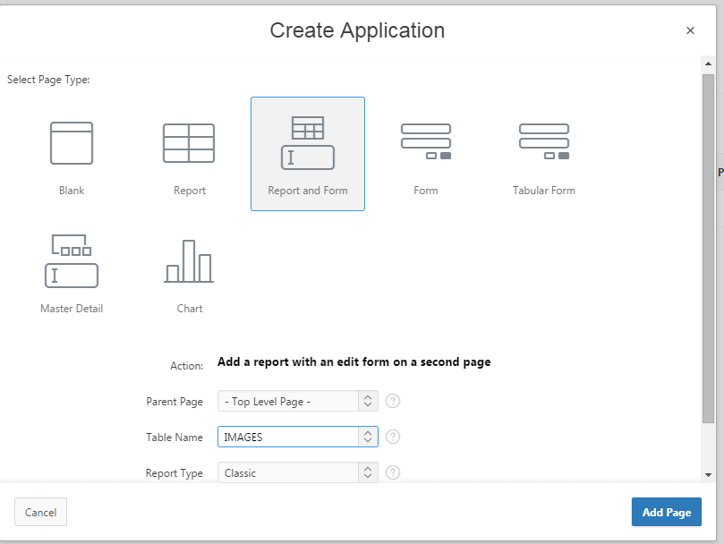

As expected, two pages are created.

Continue to create the application and then run it.

After the login page, navigate to the Images page. Note there is a [datatype] entry for image but the thumbnail is empty. This is expected as the image column is an object type and the thumbnail has not been created yet.

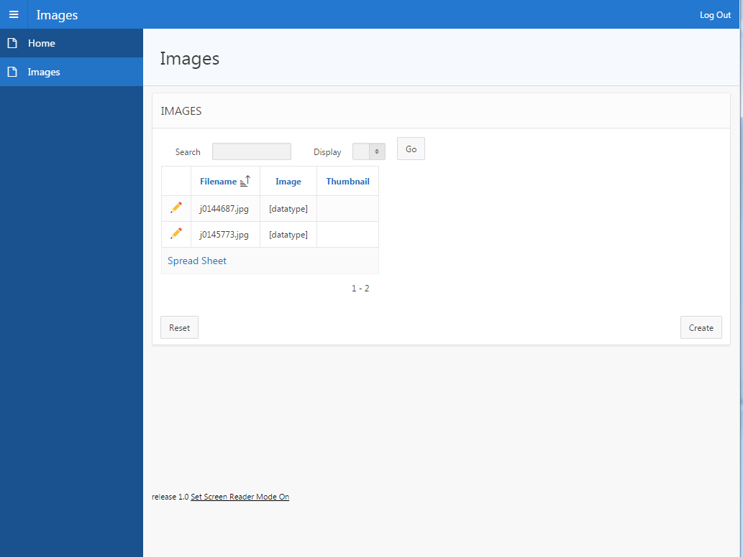

Edit this page (Page 2?) and open the Images Region

The Source SQL query viewed in the Code Editor is

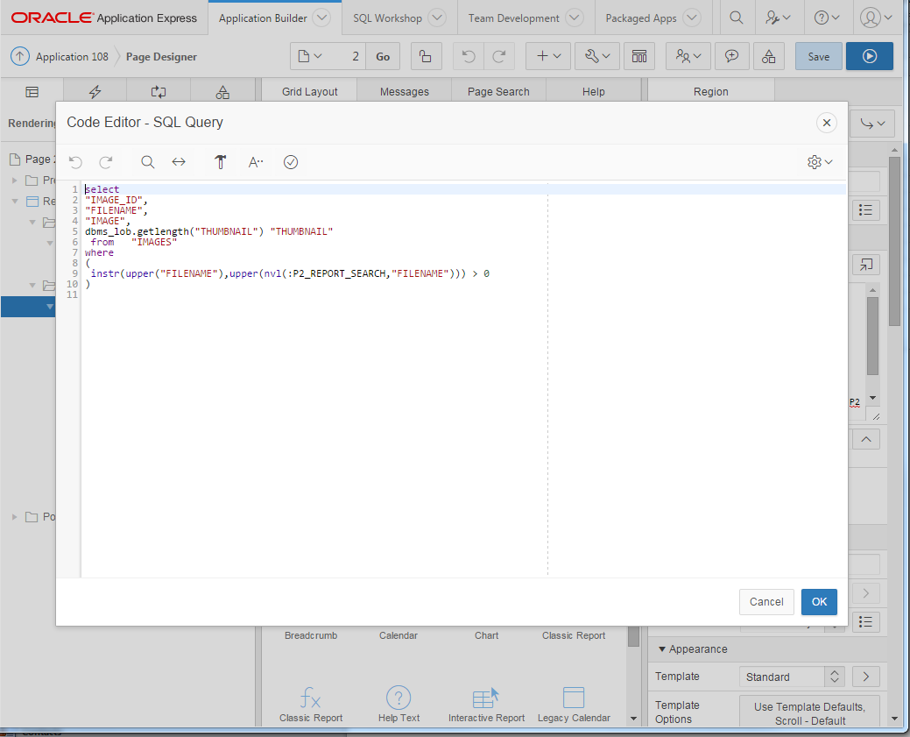

As the full size image is not needed, change the query to remove the IMAGE column

select

"IMAGE_ID",

"FILENAME",

dbms_lob.getlength("THUMBNAIL") "THUMBNAIL"

from "IMAGES"

where

(

instr(upper("FILENAME"),upper(nvl(:P1_REPORT_SEARCH,"FILENAME"))) > 0

)

and **Save** the changes. Re-run the page to ensure that the image column is not displayed.

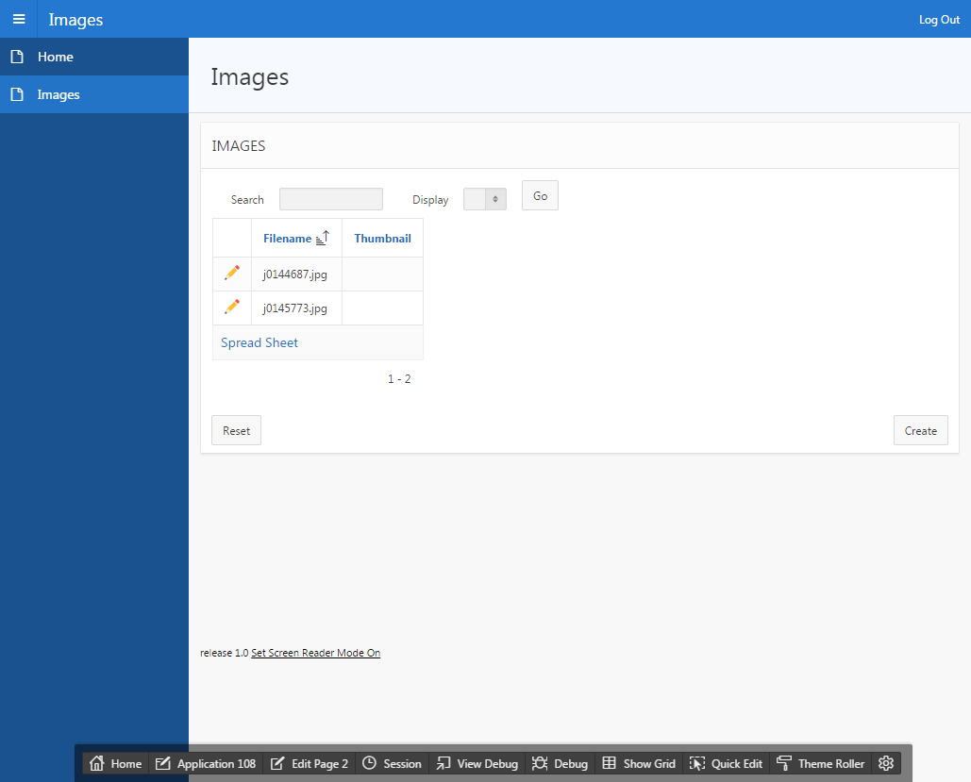

In SQL Developer, create a procedure to generate a BLOB thumbnail

CREATE OR REPLACE PROCEDURE create_blob_thumbnail (p_image_id IN INTEGER) IS

l_orig ORDSYS.ORDImage;

l_thumb ORDSYS.ORDImage;

l_blob_thumb BLOB;

BEGIN

-- lock row

SELECT image

INTO l_orig

FROM images

WHERE image_id = p_image_id FOR UPDATE;

l_thumb := ORDSYS.ORDImage.Init();

dbms_lob.createTemporary(l_thumb.source.localData, true);

ORDSYS.ORDImage.processCopy(l_orig,

'maxscale=128 128',

l_thumb);

-- extract BLOB from OrdImage

UPDATE images

SET thumbnail = l_thumb.source.localData

WHERE image_id = p_image_id;

dbms_lob.freeTemporary(l_thumb.source.localData);

COMMIT;

END;

Run the procedure for the test images

BEGIN

create_blob_thumbnail(1);

create_blob_thumbnail(2);

END;

You may need to adjust the parameters to match your image_ids.

Re-run the application again. A thumbnail can be downloaded and subsequently viewed but there is no thumbnail image being displayed in the application.

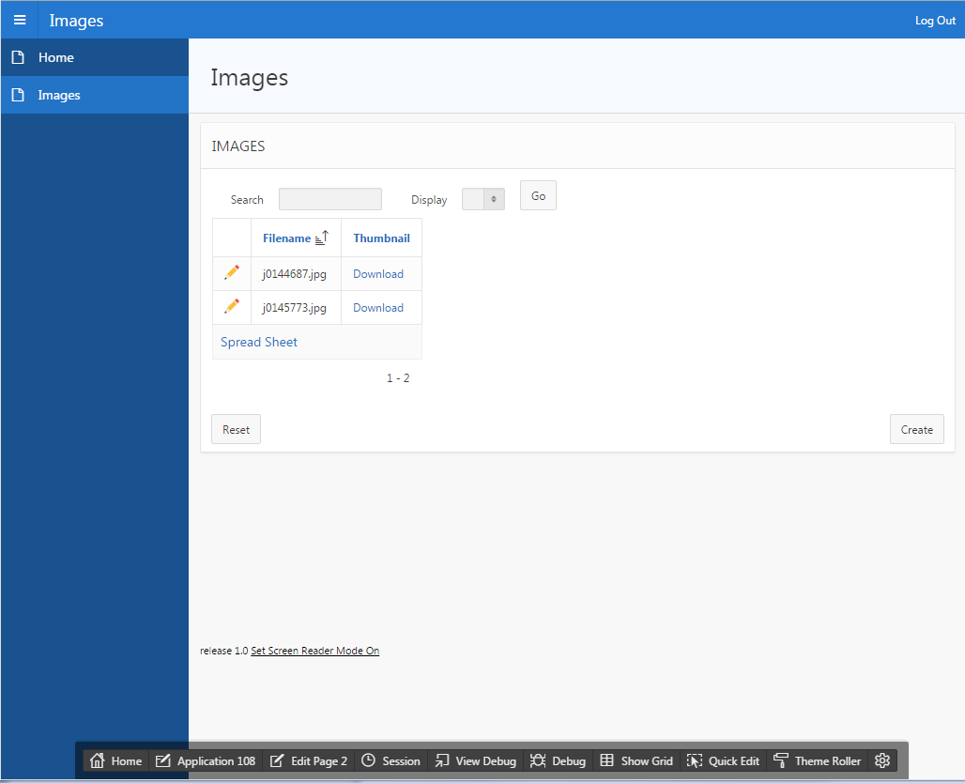

To rectify this, edit the attributes for the thumbnail column

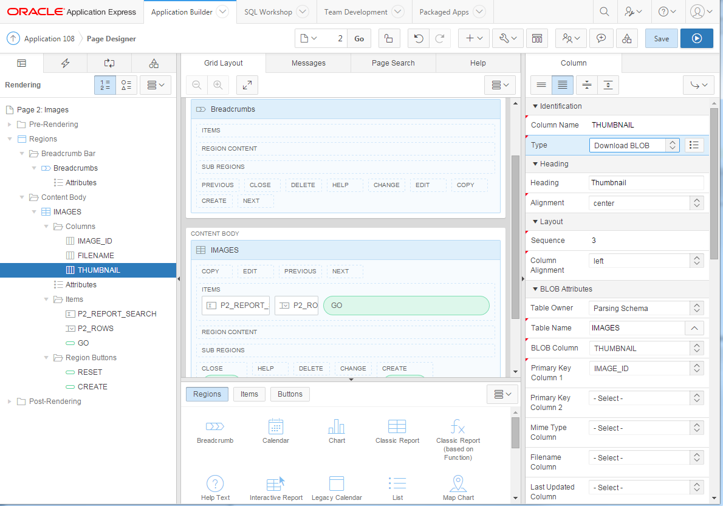

And change the Type from Download BLOB to Display Image

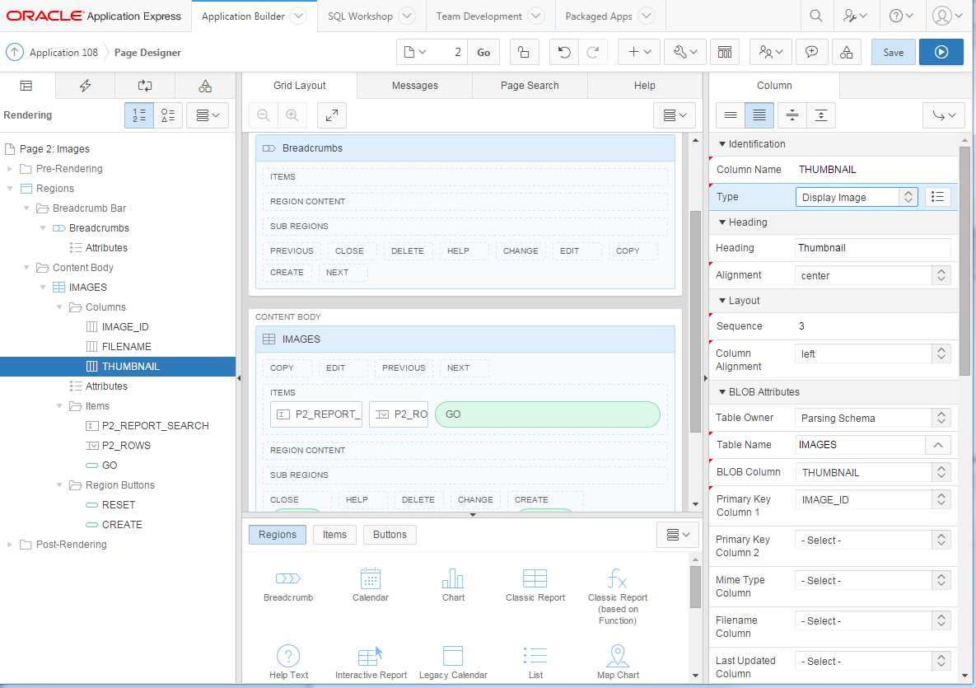

Save the change and re-run the application to view the thumbnails

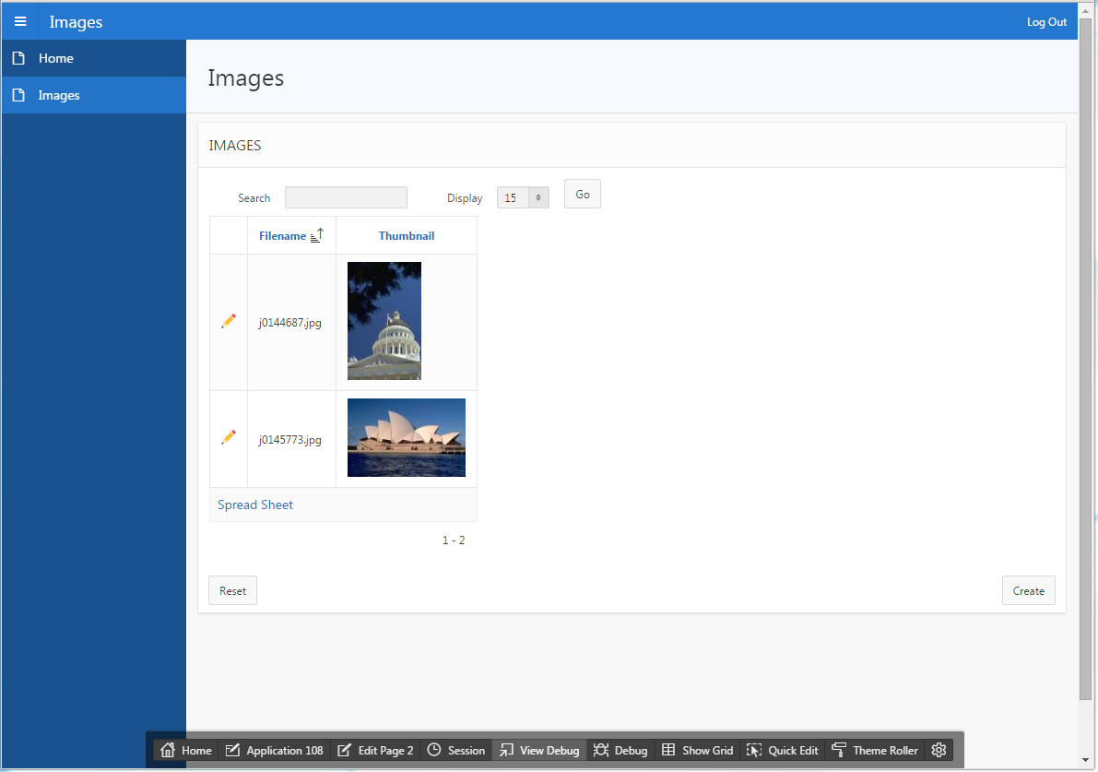

Click on the pencil icon to navigate to the Form page (Page 3?)

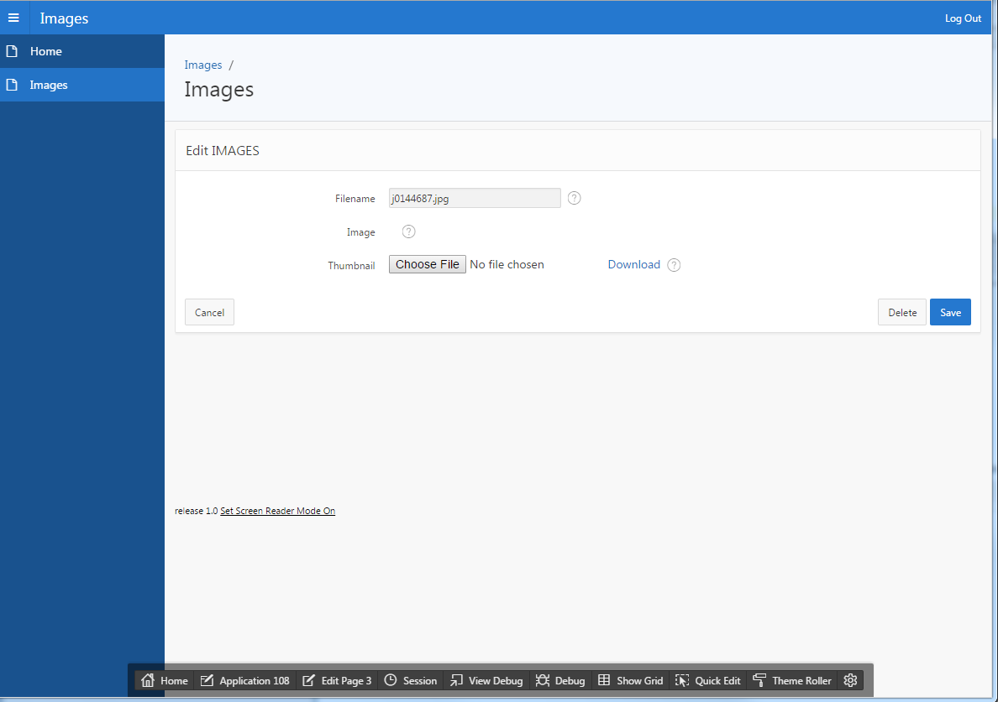

The page is rather sparse so display the full-size image here

Open the P3_IMAGE item.

Change the Type entry to **Display Image**

and change the Based On entry to **BLOB Column returned by SQL Statement** and enter[2]

SELECT i.image.getContent()

FROM images i

WHERE i.image_id = :P3_image_id

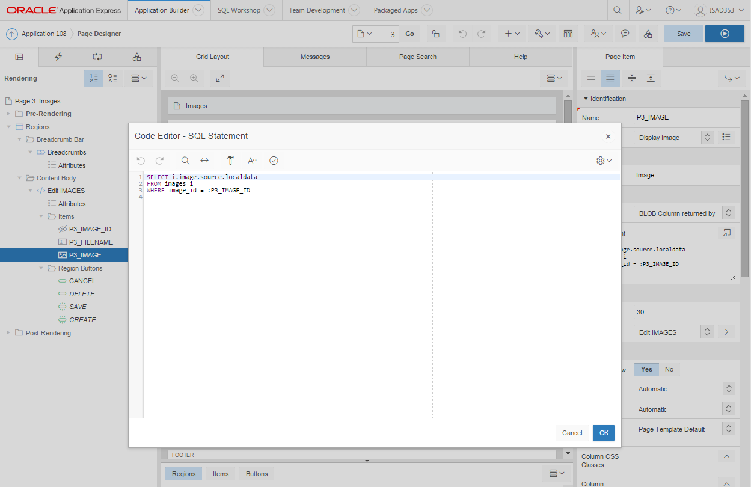

Save the changes and re-run the application – the full size image is displayed

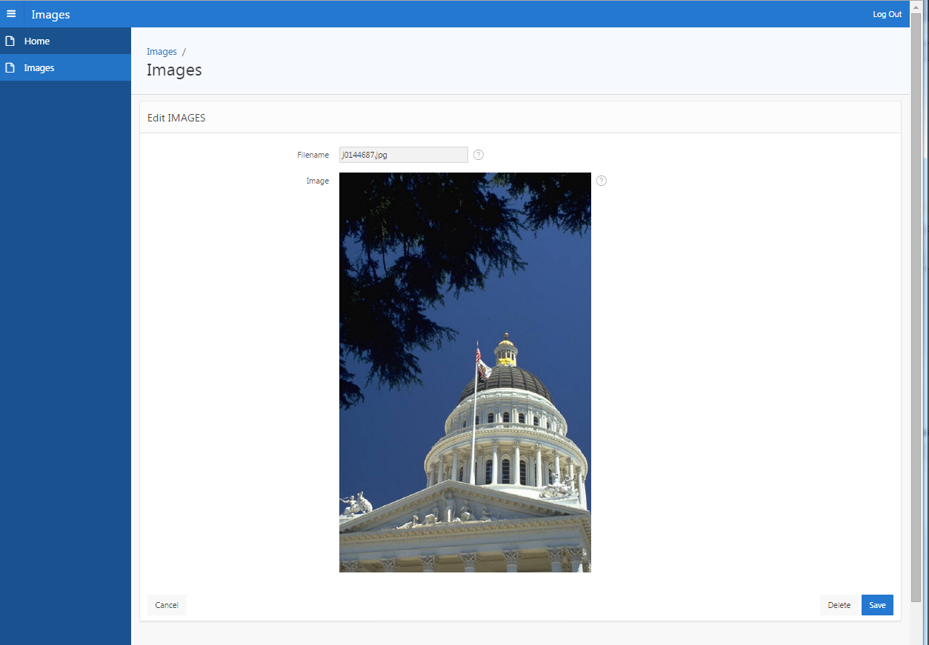

Delete the P3_THUMBNAIL item to tidy up the display

Finally to remove the Spread Sheet link on Page 2, set CSV Export Enabled to **No**

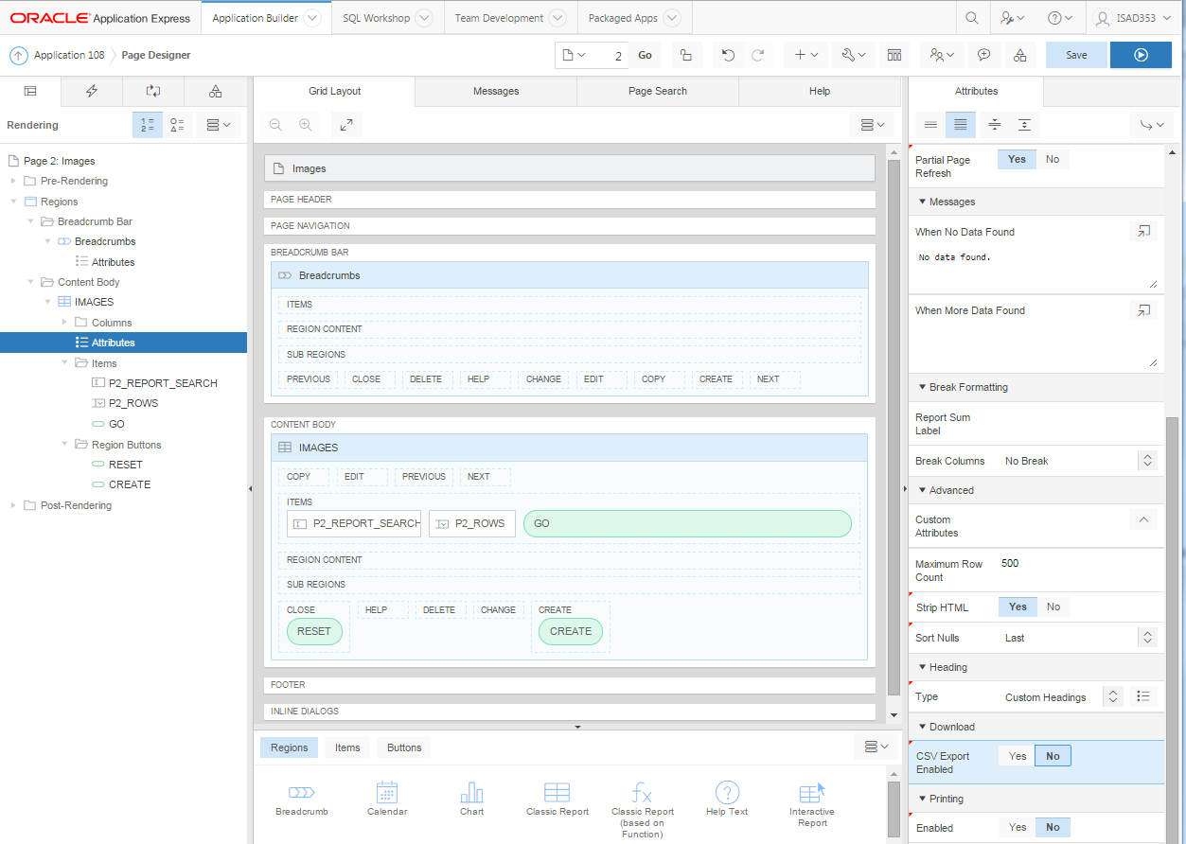

1. Note that the ISAD353_IMAGES directory has been created and populated for you as below. You should not execute this code!

   CREATE OR REPLACE DIRECTORY ISAD353_images AS 'D:\Files\Images\ISAD353_images';

   GRANT READ ON DIRECTORY ISAD353_images TO PUBLIC;
2. This is equivalent to

   SELECT i.image.source.localdata

   FROM images i

   WHERE image_id = :P3_IMAGE_ID